**Dashboard Design**

|  |  |
| --- | --- |
| Date | 30 July 2025 |
| ID | SWUID20250188226 |
| Project Name | Global Food Production Trends and Analysis (1961–2023) |
| Maximum Marks | 5 Marks |

Creating an effective dashboard involves thoughtful design to ensure that the presented information is clear, relevant, and easily understandable for the intended audience. Here are some key principles and best practices for dashboard design

**Activity 1: Interactive and visually appealing dashboards**

Creating interactive and visually appealing dashboards involves a combination of thoughtful design, effective use of visual elements, and the incorporation of interactive features. Here are some tips to help you design dashboards that are both visually appealing and engaging for users so take care of below points

* Clear and Intuitive Layout
* Use Appropriate Visualizations
* Colour and Theming
* Interactive Filters and Slicers
* Drill-Down Capabilities
* Responsive Design
* Custom Visuals and Icons
* Use of Infographics

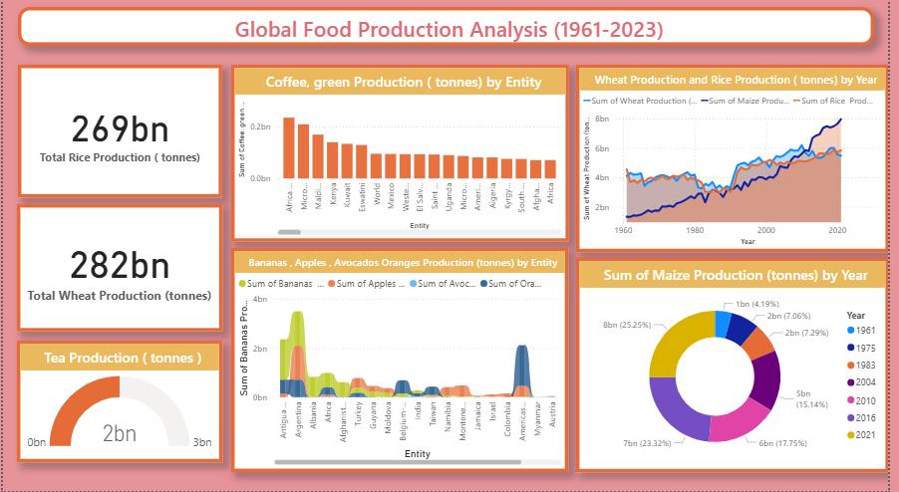

**Power BI Dashboard View**

**Summary and Outcome**

Here are five potential outcomes from the dashboard image provided:

• **Total Rice Production** stood at **269 billion tonnes**, making it another staple with consistent global demand.

• **Tea Production** was recorded at **2 billion tonnes**, indicating its limited but steady demand worldwide.

• **Coffee green production** is highest in **Brazil**, followed by **Vietnam** and **Colombia**, dominating global coffee exports.

• Among fruits, **Banana production** is significantly high in **India** and **China**, while apples, oranges, and avocados vary across other nations.

• Both **wheat and rice production** have shown steady growth since the early 2000s, with notable spikes post-2010.

• **Maize production** was highest in **2016**, contributing **23.32%** of the total maize output shown in the pie chart.

• The dashboard uses **bar charts, pie charts, Area Chart and ribbon chart** to effectively represent trends across time and entities.